# **Lines in Graphic Design**

## **Types of Lines in Art**

Art is represented by a variety of details, from style to organization to the elements of art and design. In art and design, there are several elements that are considered important concepts which can be applied to visual art. These elements of art include line, shape, color, value, form, texture, and space. Of these, lines are important as they help to distinguish the different aspects of the art.

**Lines** in art and design can be displayed in different ways. The way they are drawn or created can help to showcase different styles of art. Lines can even evoke a mood. For example, a thick, [straight line](https://study.com/learn/lesson/line-concept-examples-straight-line-geometry.html) might express orderliness or seriousness within the design. Some lines can improve the quality of the art while others can highlight certain features of it.

## **Line in Graphic Design**

* A **line** is defined as a mark connecting two points or a mark that originates as an extension from one point. It may be characterized by points as well as the edges of the objects within the artwork.
* Lines can be straight or curved, as well as dotted or dashed, and they can help to portray different aspects of the design.
* Lines can be used to express movement within the artwork which helps to demonstrate actions or motions.
* They also assist in creating boundaries. For example, a graphic design image that displays outdoor scenery can use lines to create boundaries between the foreground and the background. This helps the viewer to understand the focus of the design.
* Lines also help to outline and emphasize shapes within the design, creating a focus as well. Lines can be created in all kinds of styles as they can have different weights and lengths which can be utilized in various ways.

In general, lines can either be vertical, horizontal, diagonal, or curved:

* **Vertical lines** extend up or down in a straight line.
* **Horizontal lines** are opposite of vertical lines as they extend from left to right, or vice versa, in a straight line.
* **Diagonal lines** are straight lines that extend at an angle as a blend of the vertical and horizontal lines.
* **Curved lines** are lines that are not straight in form as they twist or wind in different ways, like a wavelength.

### **Types of Lines in Design**

Lines are used considerably in graphic design. Things such as logos, flyers, and images created for social media all make use of lines to create a design.

Artists use various methods concerning lines to convey or group information. They may also use lines to add visual effects using borders and dividers, as well as emphasizing words.

There are several different types of styles of lines used in graphic design, including contour lines, implied lines, gestural lines, and regular and irregular lines.

* **Contour lines** are used in graphic design to accent an object by providing an outline or edge. Contour lines can add visual effects to enhance the design or can be used to emphasize a certain aspect of the design;
* **Implied lines** are used to characterize a boundary or a change in the artwork. Implied lines are not actual lines but they are used to suggest that there is a boundary. A dotted line or a series of items that differentiates a portion of the design are implied lines.
* **Gestural lines** indicate a motion or a gesture. Gestural lines can be used to indicate movement or emotion.
* **Regular lines** are clear in their indication and direction
* **Irregular lines** may not follow a rhythm or clear direction.

Lines may also be classified as continuous lines (meaning they stay connected) or interrupted lines (meaning they are disconnected at times), such as dotted lines.

## **Examples of Lines in Graphic Design**

Lines can be used in many ways in graphic design. Some are used more plainly to represent a boundary, while others are used to construct a more complex object.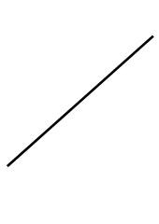

As mentioned in the definition, a line is simply a connection of two points; however, in this example there are no points to reference. Though there aren't clear points established, it is still clear where the line begins and ends.

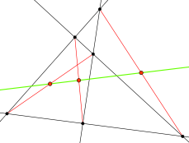

Other examples may show many lines that are used together. For example, lines can be created with different colors and continue in different directions as seen in this image (**intersecting image**):

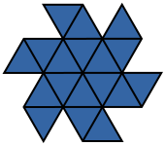

In graphic design, lines are typically used to form a unique design. They can become more complex as they are used to create more distinct designs. When many lines are used together, they can form new ideas, shapes, and objects.***Graphic design image using lines.***

|  |
| --- |